Rescuing Influenza virus

**DAY 1**

* Sending plasmids on filter paper
  + Mark a circled area with a pencil (not a marker pen) on a clean Whatman #1 filter paper (or equivalent).
  + Spot about 2 µg of plasmid DNA into the circle. Allow the filter paper dry at room temperature.
  + Insert spotted filter paper inside a plastic bag and heat-seal it.
  + Send by regular (air) mail.
* Receiving plasmids on filter paper
  + To recover the DNA, use clean gloves and cut the marked circle area that contains the dried plasmid DNA.
  + Using clean forceps, insert the filter paper into a 1.5 ml micro centrifuge tube.
  + Add 100 µl of TE buffer, vortex briefly and incubate at room temperature for 5 minutes (UP TO 30 MINUTES, NOT OVERNIGHT AS DON’T WANT DEGREDATION OF DNA).
  + Vortex again and centrifuge the tube for a few seconds.
  + Remove eluent for further use
    - Check DNA concentration with nanodrop
  + Store the remainder of the filter paper/TE mix at -20 or -80 C
* Transformation Electro-Competent *E. Coli* (DH10B)
  + 10 pg of DNA in volume of 1 µl added to 25 µl of *E. Coli*
  + Mixture transferred to cuvette
  + electroporation
    - 25 µF, 200 Ω, 1.8 kV
    - Pulse time ideally above 5 ms
  + Add 1 ml of SOC (Super Optimal broth with Catabolic repressor)
  + Plate 1/10 (100 µl)
    - save remaining electroporation product at 4°C as backup
  + Incubate plates in warm room at 37°C O/N

**DAY 2**

* Pick 2 colonies per plasmid
* Add to 5 ml LB with 5 µl of Ampicillin (Ampicilin: 100 mg/ml)
* Grow on shaker at 37°C in warm room O/N
* Store plates at 4°C
  + Wrap in parafilm

**DAY 3**

* Prepare glycerol stocks of clones that grew O/N
  + 750 µl bacteria + 250 µl 100% Glycerol
  + Store at -80°C
* Transfer 1.5 ml 2x 🡪 2 1.5 ml Eppendorf
* Centrifugation for 5 min at 10,000-13,000xg
* Miniprep protocol



* Check DNA concentration with nanodrop 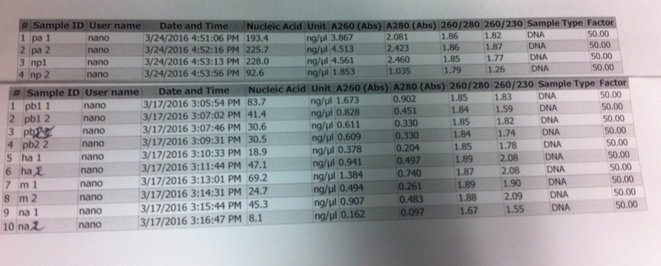
* Send off for sanger sequencing to confirm correctness of the different plasmids

**Influenza virus rescue transfection**

* OptiMEM-Lipofectamine 2000 (LPF2000) mixture: Prepare 250 μl of OptiMEM media and 6-8 μl of LPF2000 per transfection. Incubate for 5-10 minutes at room temperature (RT). Meanwhile, prepare the plasmid transfection mixture.
* Plasmid transfection mixture: Prepare the plasmid transfection cocktail in 50 μl of OptiMEM media. We usually use 1 μg of each influenza DNA plasmid per rescue. Add 1 μl of the pDZ plasmids (at 1 μg/μl) PB2, PB1, PA, HA, NP, NA, M, and NS to a tube containing 50 μl of OptiMEM media.
* OptiMEM-LPF2000-DNA plasmid mixture: Add 250 μl from step 1.1 into the influenza DNA plasmid transfection mixture (step 1.2). Incubate this mixture for 20-30 minutes at RT. Meanwhile, prepare suspensions of 293T and MDCK cells for transfection.
* During incubation:
  + Preparation of 293T/MDCK co-culture: Before starting, bring the PBS 1X, DMEM 10%FBS 1% PS media, and EDTA-trypsin mixture to 37°C. The density of the cells should be at 80-90% confluence the day of transfection. Usually, one confluent 100 mm dish of 293T and one confluent 100 mm dish of MDCK cells can be used for 10-12 rescues. We are going to use 250 μl of cells per well. Both cell lines will be resuspended in a total of 3 ml of DMEM 10%FBS 1% ABAM.
    - Carefully resuspend each cell line in 10 ml of DMEM 10%FBS 1%PS in a 15 ml centrifuge tube. You will have one tube for 293T cells and one tube for MDCK cells.
    - Spin down
    - Resuspend the 293T cells in 3 ml of DMEM 10%FBS 1%PS and when resuspended, deliver the 3 ml to the MDCK cells to resuspend those cells. This will give you the mixture of 293T and MDCK cells to be used for your co-culture.
    - Add 250 μl of the 293T/MDCK cells per well (10-12 6-well wells).
* After 20-30 minutes RT incubation, add 1 ml of DMEM 10%FBS 1%PS to the OptiMEM-LPF2000-influenza DNA plasmid mixture
* Add the 1.3 ml into the wells with the 250 μl of 293T/MDCK cells
* Gently shake the 6-well-plate and let the transfection incubate overnight (ON) in the incubator at 37°C and 5% CO2
* Next day, approximately 16-24 hours post-transfection, change the transfection media and incubate the transfected cells in DMEM 0.3%BSA 1%ABAM containing 1 μg/ml of TPCK-trypsin for 48 hours
* After 48 hours of changing the media, transfer the supernatant from the transfected cells into a microcentrifuge tube
* Centrifuge the tissue culture supernatant in a microcentrifuge for 1-2 minutes, 13,000 rpm
* Infect fresh MDCK cells in 6-well plates (plated the day before) with 200 μl of centrifuged tissue culture supernatants.
* Incubate the cells at 37°C for 2-3 days.
* At 48-72 hours after passage, depending on the transfection efficiency and the virus load, a cytopathic effect (CPE) will be observed in the MDCK infected cells. CPE suggests a successful rescue. However, an HA assay should still be performed to confirm the presence of the virus in the tissue culture supernatants

**HA assay to confirm the rescue of influenza viruses**

* Dispense 50 μl of PBS 1X into each well of the V-bottom 96-well plate.
* Add 50 μl of the MDCK tissue culture supernatants and/or allantoic fluid from the infected eggs to the first well and, make 2-fold serial dilutions for the following wells. Discard the extra 50 μl from the last well.
* Add 50 μl of 0.5%-1.0% chicken red blood cells (prepared in PBS 1X) to each well.
* Incubate the V-bottom 96-well plate for 30-45 minutes (until a red dot is visible in the bottom of a negative control PBS sample) on ice. Read and interpretate the results as indicated below



**Relevant Publications**

* Martínez-Sobrido, Luis, and Adolfo García-Sastre. "Generation of recombinant influenza virus from plasmid DNA." JoVE (Journal of Visualized Experiments) 42 (2010): e2057-e2057.